**\*\*Part 1\*\***

**Account_Holder**

|  |  |  |  |  |  |  |
| --- | --- | --- | --- | --- | --- | --- |
| UserName | password | first_name | last_name | address | email |  |

**Vacation_Spot (used to be just Location)**

|  |  |  |  |
| --- | --- | --- | --- |
| location_ID | address | spot_name |  |

**Favorites**

|  |  |  |  |
| --- | --- | --- | --- |
| Username | locations | address |  |

**Car Rental**

|  |  |  |  |  |  |
| --- | --- | --- | --- | --- | --- |
| Rental_ID | rental_company | mile_limitation | cost_per_day | Address |  |

**Hotel**

|  |  |  |  |  |  |  |
| --- | --- | --- | --- | --- | --- | --- |
| Hotel_ID | distance | cost_per_night | Hotel_name | Availability | Hotel_address |  |

**Restaurants**

|  |  |  |  |  |  |  |
| --- | --- | --- | --- | --- | --- | --- |
| Restaurant_ID | food_type | price_range | avg_wait | rating | address |  |

**Reviews**

|  |  |  |  |  |  |  |
| --- | --- | --- | --- | --- | --- | --- |
| Review_ID | Rating | Comment | Rental_ID | Hotel_ID | Restaurant_ID |  |

**\*\*Part 2\*\***

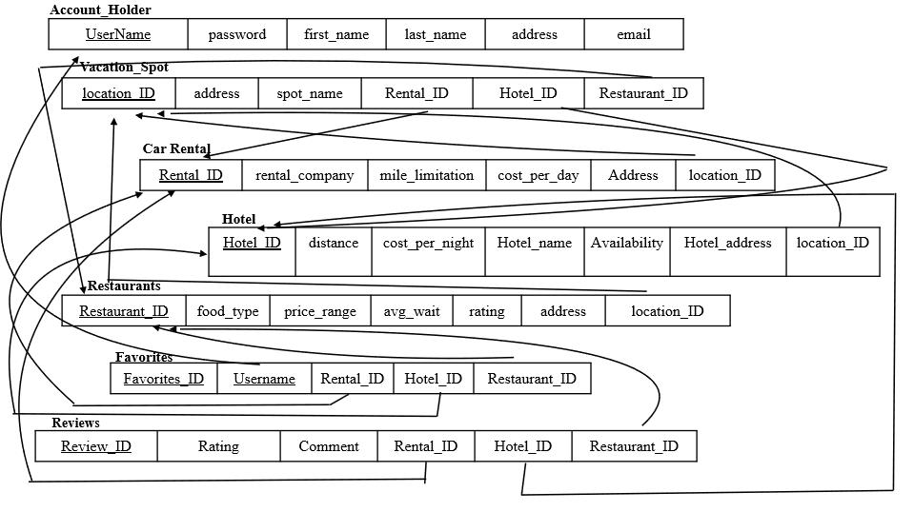

**\*\*Part 3\*\***

CREATE TABLE Account_Holder

(Username VARCHAR(30) NOT NULL,

password VARCHAR(20) NOT NULL,

first_name CHAR(20) NOT NULL,

last_name CHAR(20) NOT NULL,

address VARCHAR(50) NOT NULL,

email VARCHAR(25) NOT NULL,

PRIMARY KEY (Username),

);

CREATE TABLE Vacation_Spot

(Location_ID INTEGER(30) NOT NULL,

address VARCHAR(50) NOT NULL,

spot_name VARCHAR(20) NOT NULL,

Rental_ID INTEGER(30) NOT NULL,

Hotel_ID INTEGER(30) NOT NULL,

Restaurant_ID INTEGER(30) NOT NULL,

PRIMARY KEY (Location_ID),

FOREIGN KEY (Rental_ID)

REFERENCES Car_Rental

ON DELETE CASCADE

ON UPDATE SET DEFAULT

FOREIGN KEY (Hotel_ID)

REFERENCES Hotel

ON DELETE CASCADE

ON UPDATE SET DEFAULT

FOREIGN KEY (Restaurant_ID)

REFERENCES Restaurants

ON DELETE CASCADE

ON UPDATE SET DEFAULT

);

CREATE TABLE Favorites

(Username VARCHAR(30) NOT NULL,

Favorites_ID INTEGER(30) NOT NULL,

Rental_ID INTEGER(30) NOT NULL,

Hotel_ID INTEGER(30) NOT NULL,

Restaurant_ID INTEGER(30) NOT NULL,

PRIMARY KEY (Username, Favorites_ID),

FOREIGN KEY (Rental_ID)

REFERENCES Car_Rental

ON DELETE CASCADE

ON UPDATE SET DEFAULT

FOREIGN KEY (Hotel_ID)

REFERENCES Hotel

ON DELETE CASCADE

ON UPDATE SET DEFAULT

FOREIGN KEY (Restaurant_ID)

REFERENCES Restaurants

ON DELETE CASCADE

ON UPDATE SET DEFAULT

);

CREATE TABLE Car_Rental

(Rental_ID INTEGER(30) NOT NULL,

rental_company VARCHAR(20) NOT NULL,

mile_limitation VARCHAR(10) NOT NULL,

cost_per_day VARCHAR(20) NOT NULL,

address VARCHAR(50) NOT NULL,

Location_ID INTEGER(30),

PRIMARY KEY (Rental_ID),

FOREIGN KEY (Location_ID)

REFERENCES Vacations_Spot

ON DELETE CASCADE

ON UPDATE SET DEFAULT

);

CREATE TABLE Hotel

(Hotel_ID INTEGER(30) NOT NULL,

distance VARCHAR(20) NOT NULL,

cost_per_night VARCHAR(10) NOT NULL,

Hotel_name VARCHAR(30) NOT NULL,

Availability BOOLEAN NOT NULL DEFAULT 0,

Hotel_address VARCHAR(50) NOT NULL,

Location_ID VARCHAR(50) NOT NULL,

PRIMARY KEY (Hotel_ID),

FOREIGN KEY (Location_ID)

REFERENCES Vacations_Spot

ON DELETE CASCADE

ON UPDATE SET DEFAULT

);

CREATE TABLE Restaurants

(Restaurant_ID INTEGER(30) NOT NULL,

food_type CHAR(20) NOT NULL,

price_range VARCHAR(20) NOT NULL,

avg_wait VARCHAR(5),

rating INTEGER(2),

address VARCHAR(50) NOT NULL,

Location_ID INTEGER(30) NOT NULL,

PRIMARY KEY (Restaurant_ID),

FOREIGN KEY (Location_ID)

REFERENCES Vacations_Spot

ON DELETE CASCADE

ON UPDATE SET DEFAULT

);

CREATE TABLE Reviews

(Review_ID INTEGER(30) NOT NULL,

Rating INTEGER(1),

Comment VARCHAR(100),

Rental_ID INTEGER(30) NOT NULL,

Hotel_ID INTEGER(30) NOT NULL,

Restaurant_ID INTEGER(30) NOT NULL,

PRIMARY KEY (Review_ID),

FOREIGN KEY (Rental_ID)

REFERENCES Car_Rental

ON DELETE CASCADE

ON UPDATE SET DEFAULT

FOREIGN KEY (Hotel_ID)

REFERENCES Hotel

ON DELETE CASCADE

ON UPDATE SET DEFAULT

FOREIGN KEY (Restaurant_ID)

REFERENCES Restaurants

ON DELETE CASCADE

ON UPDATE SET DEFAULT

);